|  |  |
| --- | --- |
| 《epay Project》  **Deployment and maintenance Manual** | |
| **V1.0** | |
|  |

|  |
| --- |
|  |

**Contents**

《epay Project》 1

Part1 Software inventory and version 3

1、Software inventory 3

Part2 Mobile Client Installation 3

2、Mobile Client Installation 3

Part1 Software inventory and version

### 1、Software inventory

1.1、Mobile Client Installation

Part2 Mobile Client Installation

### 2、Mobile Client Installation

Find the installation package in the phone location, click the installation package

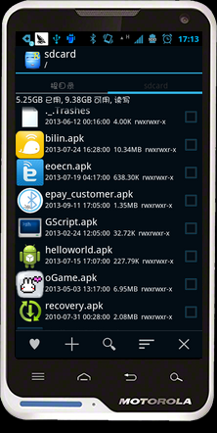

Pop up Operation selection box, click on the ‘Install’ button

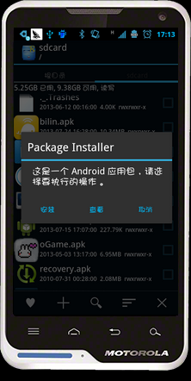

Pop up confirmation box, click Install

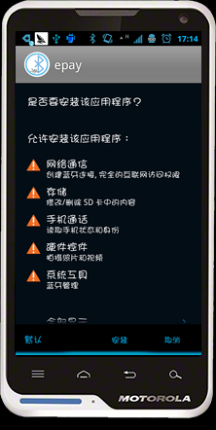

Installing

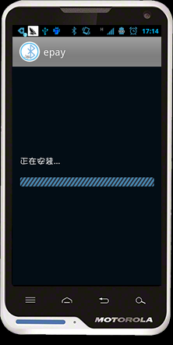

The installation is complete, click the ‘Finish’ button

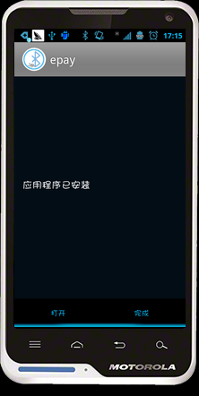

In the application list, you can find the successful installed software

